Tight Coupling, Loose Coupling & Dependency Injection (DI)

1. Why Coupling Matters in Real Projects
In any real-world application, we never work with a single class.
Applications are built using:
- Multiple classes
- Each class depending on others
- Objects collaborating to deliver functionality
The way these classes depend on each other decides how flexible, testable, and maintainable the application becomes.
This is where coupling comes into play.

2. What Is Tight Coupling?
Tight coupling occurs when:
- One class directly creates another class
- The dependency is hard-coded
- Changes in one class force changes in another
Real-life analogy
A mobile phone that supports only one telecom provider.
No freedom. No replacement. No flexibility.

3. Tight Coupling – Java Example
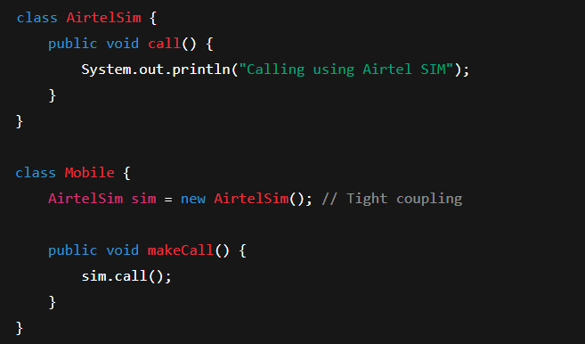
Problems with this approach:
- Mobile is permanently tied to Airtel Sim
- Cannot switch to Jio or Idea without changing code
- Hard to test
- Violates good design principles
This is tight coupling.

4. Why Tight Coupling Is Dangerous in Enterprise Apps
In enterprise applications:
- Business requirements change frequently
- Implementations evolve
- Dependencies must be replaceable
Tight coupling leads to:
- Fragile code
- Difficult refactoring
- High maintenance cost
We need flexibility.
5. Loose Coupling – The Correct Approach
Loose coupling means:
- Classes depend on abstractions, not implementations
- Dependencies are provided from outside
- Implementation can change without breaking code
Real-life analogy
A mobile with a SIM slot.
The phone depends on a SIM — not on Airtel, Jio, or Idea specifically.

6. Introducing Abstraction (Interface)
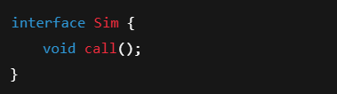
Implementations:
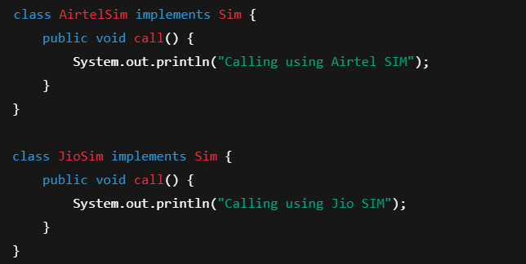

7. Loose Coupling – Java Example
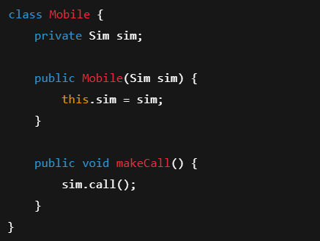
Usage:
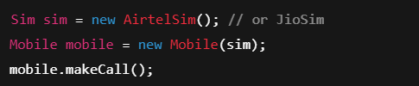
Now:
- Mobile depends only on Sim interface
- Implementation can change at runtime
- No code modification needed inside Mobile
This is loose coupling.

8. What Is Dependency Injection (DI)?
Dependency Injection means:
Instead of creating dependencies inside a class,
they are injected from outside.
In simple terms:
- Don’t use new inside business classes
- Let someone else provide the dependency

9. Types of Dependency Injection
1. Constructor Injection (Recommended)
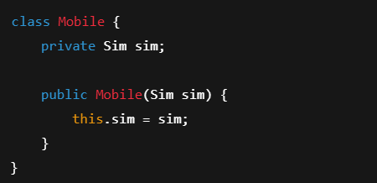
✔ Immutable
✔ Mandatory dependency
✔ Best for testing

2. Setter Injection
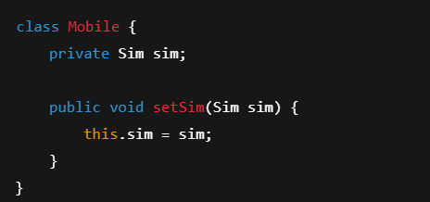
✔ Optional dependency
✔ Flexible

3. Field Injection (Not Recommended)
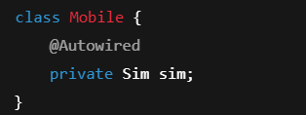
❌ Hard to test
❌ Hidden dependencies

10. How Spring Fits In
Spring:
- Creates objects
- Decides which implementation to inject
- Wires dependencies automatically
- Manages lifecycle
You declare what you need, Spring provides how it is created.
This is where:
- Loose coupling
- Dependency Injection
- Inversion of Control
come together.

11. Interview Perspective (Very Important)
If asked:
“How does Spring reduce tight coupling?”
Best answer:
By enforcing programming to interfaces and injecting dependencies at runtime using Dependency Injection, thereby achieving loose coupling through Inversion of Control.

